How to sign-up for a NEXT Enrichment Class

#1 Go to my Payments Plus
(if you do not have an account you will need to set one up)
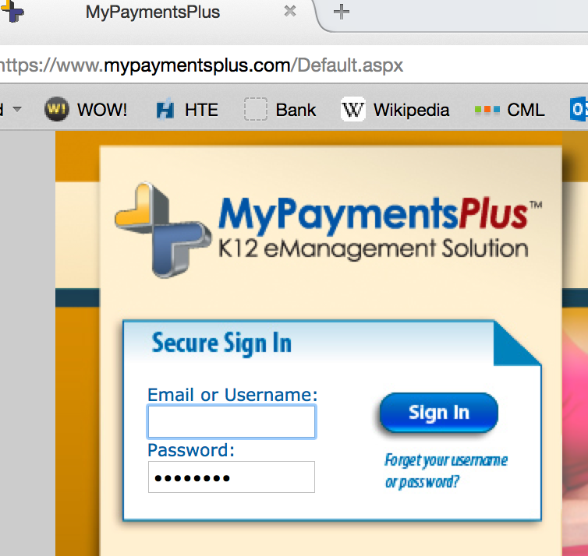

#2 Log in and look under “Other Payments”
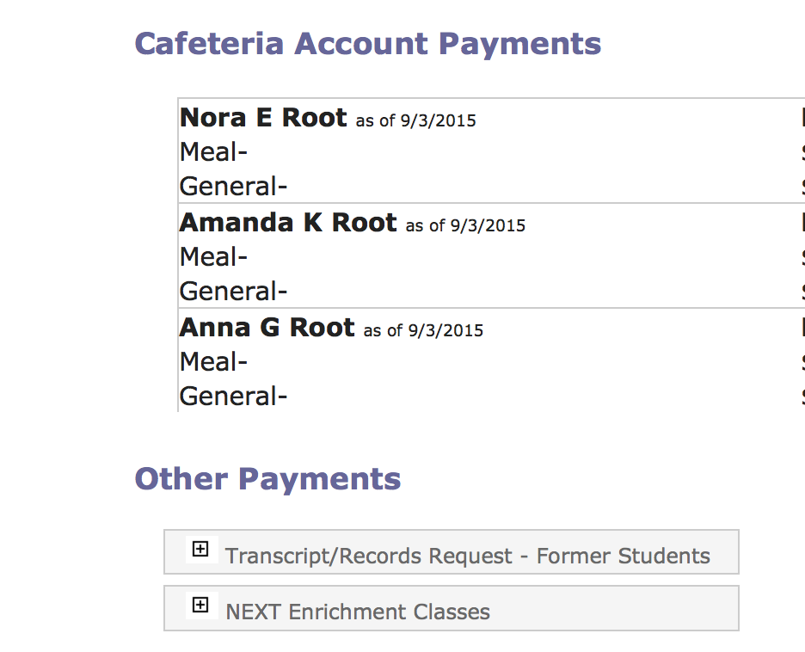

#3 Choose “NEXT Enrichment Classes” and all Enrichment classes available to your child will appear
